# Overview

This document contains the necessary information to use the Willow Joystick, a low force magnetic joystick designed for users with limited finger mobility and strength.

Contents

Overview 1

Introduction 3

Features 3

Joystick Features 3

Hub Features 5

Specifications 7

Compatibility 7

Usage 8

Initial Setup 8

Connecting to Host Device 12

Powering the Device 12

Setting Up Host Device 18

Operating the Willow 20

How to Perform Willow Inputs 20

USB & Wireless Mouse Mode 21

USB Gamepad Mode 23

USB Gamepad Mode connected to an Android Smart Phone or Tablet 24

Mapping Summary 24

The Hub Menu 27

Accessing the Hub Menu 27

Navigating the Hub Menu 27

Hub Menu Options 27

Adjusting the Willow 30

Input-Output Mapping 33

Changing Settings Through the Serial Interface (API) 33

Storage 33

Care 33

Cleaning the Willow 33

Troubleshooting 33

Contacting Support 34

Disposal 34

## Introduction

The Willow is a low force joystick, developed from the magnetic gimbal used in the LipSync. The device allows users with limited strength and range of motion to use a joystick for computer access and gaming.

## Features

### Joystick Features

Figure 1:Willow base showing mounting nuts(left), Willow with nonslip base attached(right)

**Topper:** The Willow has a swappable topper that can be unscrewed and replaced depending on the user’s preference.

**Orientation Arrow:** This arrow on the enclosure of the Willow Joystick points towards the ‘up’ direction, allowing the user to orient themselves while using the joystick.

**Cable Jack:** The Willow Hub plugs into this port using the Willow Interface Cable.

**Mounting Nuts:** The Willow Joystick has two built in M3 nuts that can be used to connect either a ¼-20 mounting adapter, a RAM B mounting adapter, or a nonslip base.

**Non Slip Feet:** The optional non slip base has 4 non slip feet that prevent the Willow Joystick from sliding around on the table during normal use.

### Hub Features

**Hub Display:** The Hub Display allows the users to make quick adjustments to device settings, calibrate the joystick, and change the operating mode. It also displays mode and version information upon start-up.

**Next & Select Buttons**: The Next and Select Buttons on the Hub allows a support person to access the Hub Menu without the need to use the assistive switch ports.

**Feedback Speaker:** The Feedback Speaker gives auditory feedback through beeping tones. The sound can be turned on or off through the Hub Menu.

**Feedback Lights:** The Feedback Lights give visual feedback through flashing on input durations. Each light represents a specific set of inputs.

**Operating Mode Indicator:** The Operating Mode Indicator is used to show whether the device is in USB Mouse, Wireless Mouse, or USB Gamepad mode.

**Microcontroller Reset:** The Microcontroller Reset hole allows access to the reset pin on the microcontroller using a paperclip or similar sized object.

**Mounting Connection:** The Hub can be mounted in view beside the host device screen so that it is easy to see/hear the feedback and read the Menu Screen when adjusting settings. The ¼-20 threads are the same as a standard camera mount.

**Joystick Port:** The Willow Joystick plugs into this port using the Willow Interface Cable.

**USB Port:** This port provides the device with power and can also be the direct connection to the host device.

**Assistive Switch Ports:** Up to 3 assistive switches with 3.5 mm audio plugs can be connected to the Willow Hub.

## Specifications

|  |  |  |
| --- | --- | --- |
| Item | Willow Joystick | Willow Hub |
| Size (Length x Width x Height) [mm] | 87 mm x 75 mm x 42 mm | 104 mm x 29 mm x 72 mm |
| Mass [g] | 93 g | 90 g |
| Power Consumption | ~0.1 W (20 mA @ 5 V) | |
| Joystick Angular Range | ± 7.5° | N/A |
| Joystick Movement Range | ± 5mm | N/A |
| Operating Force | 25 grams force | N/A |

## Compatibility

|  |  |  |  |  |
| --- | --- | --- | --- | --- |
| Operating System | | Compatibility per Mode | | |
| USB Mouse | Wireless Mouse | USB Gamepad |
| Phone/Tablet | Android | Checkmark with solid fill1 | Checkmark with solid fill | Checkmark with solid fill1 |
| iOS2 | Checkmark with solid fill | Checkmark with solid fill |  |
| iPadOS | Checkmark with solid fill | Checkmark with solid fill |  |
| Windows | Checkmark with solid fill | Checkmark with solid fill | Checkmark with solid fill |
| Desktop | macOS | Checkmark with solid fill | Checkmark with solid fill |  |
| Linux | Checkmark with solid fill | Checkmark with solid fill |  |
| Windows | Checkmark with solid fill | Checkmark with solid fill | Checkmark with solid fill |
| 1 Only with devices with USB OTG HID (Universal Serial Bus On-The-Go Human Interfere Device)  2 Only for iOS13+ and iPadOS. | | | | |

The Willow is compatible with host devices that support a USB Mouse, a Bluetooth Mouse, or a USB-HID Gamepad. This includes Windows, macOS and Linux computers, most Android and Windows phones and tablets, and Apple iOS phones and tablets with iOS13 and iPadOS. Not all mobile phones and tablets support external pointing devices like the Willow or other mouse replacements. Check with the manufacturer before purchasing. Look to see if your device supports “USB OTG HID” or “Universal Serial Bus On-the-Go Human Interface Device” profile.

# Usage

### Initial Setup

This section outlines the necessary and optional steps to set up the Willow Joystick.

#### Mount the Willow Joystick

The first step to mounting the Willow Joystick is to determine where it is to be mounted. The joystick can be mounted on a mounting arm, or it can be placed on a table or other flat surface.

When mounting on a mounting arm, one of the mounting arm adaptors can be attached to the joystick using two M3 screws to attach either a ¼-20 camera thread or a RAM B ball mount to the joystick. When mounting on a desk, the same M3 nuts can be used to attach a nonslip foot plate to the bottom of the joystick to prevent it from sliding around during normal use.

Figure 2: Willow Joystick with 1/4-20 Adaptor(left), Nonslip Base(right)

For some users, the height of the Willow Joystick while placed on the table may make it difficult to use. The Willow includes print files and design files for a parametric wrist rest, which is a ramp with a variety of adjustable parameters to create a custom ramp to raise the user’s wrist to a level that is more comfortable.

#### Mount the Willow Hub

The Willow Hub should be mounted or placed in a location within view of the user. Ideally the Willow Hub is located within 1 m of the user, near the host device screen. Like the Joystick, the Willow Hub has a female ¼”-20 UNC threaded mounting connection on the back side of the device.

**Using a mounting arm**

1. Position your mounting arm so it does not interfere with your view of the screen so that the ¼-20 threaded end sits where you want to mount the Hub.
2. Connect the Hub to the Mounting Arm using the ¼-20 threads.
3. Adjust your mounting arm as needed to position the Hub specifically where you want it to be.

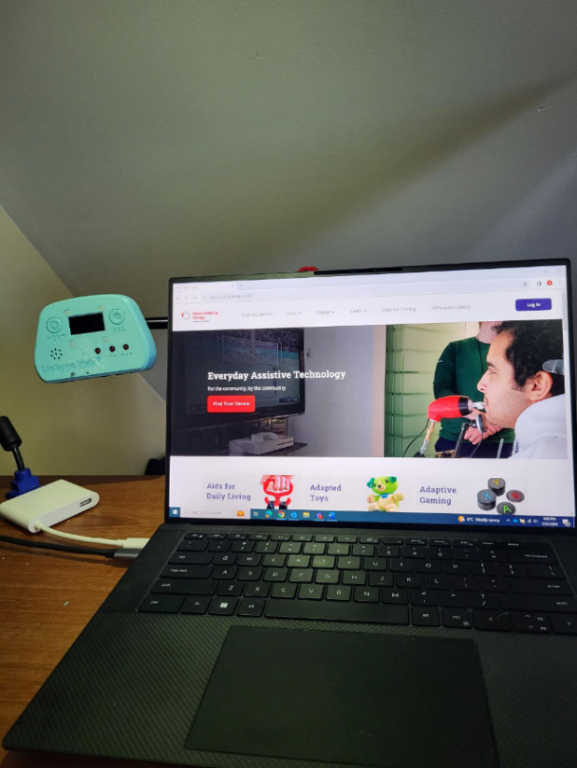

**Mounted on a desk or table**

1. Clear a space for the Hub to sit on the desk near the monitor. The Hub can rest on the back surface or can be connected to an optional desktop stand.
2. If using, mount the Hub in the stand with a ¼-20 bolt.
3. Place the Hub in the cleared off spot.

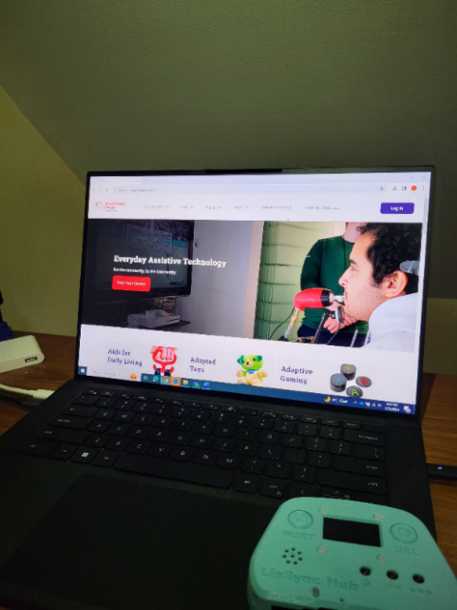

#### Connect the Willow Joystick to the Willow Hub

The Willow Joystick must be connected to the Willow Hub using the Willow Interface Cable. Attach one end of the cable to the Hub Port on the Willow Joystick. Attach the other end of the cable to the Joystick Port on the Willow Hub, which is labelled “JOY”. Ensure the cable is routed and secured appropriately to keep it from getting snagged or damaged.

Ensure you plug in the Willow Interface Cable in the correct orientation. The tab side of the plug inserts into the narrower side of the outlet.

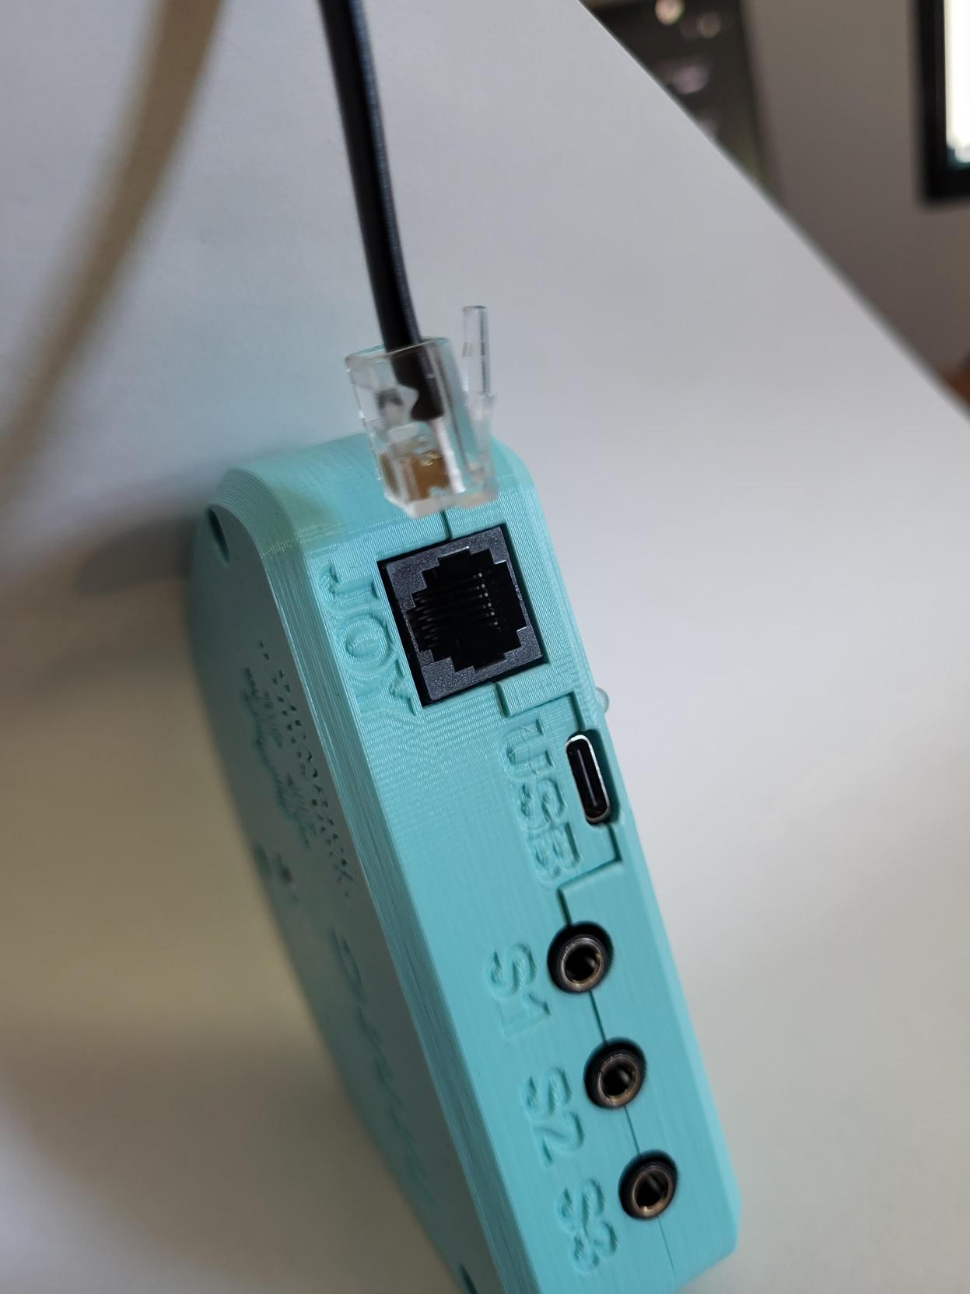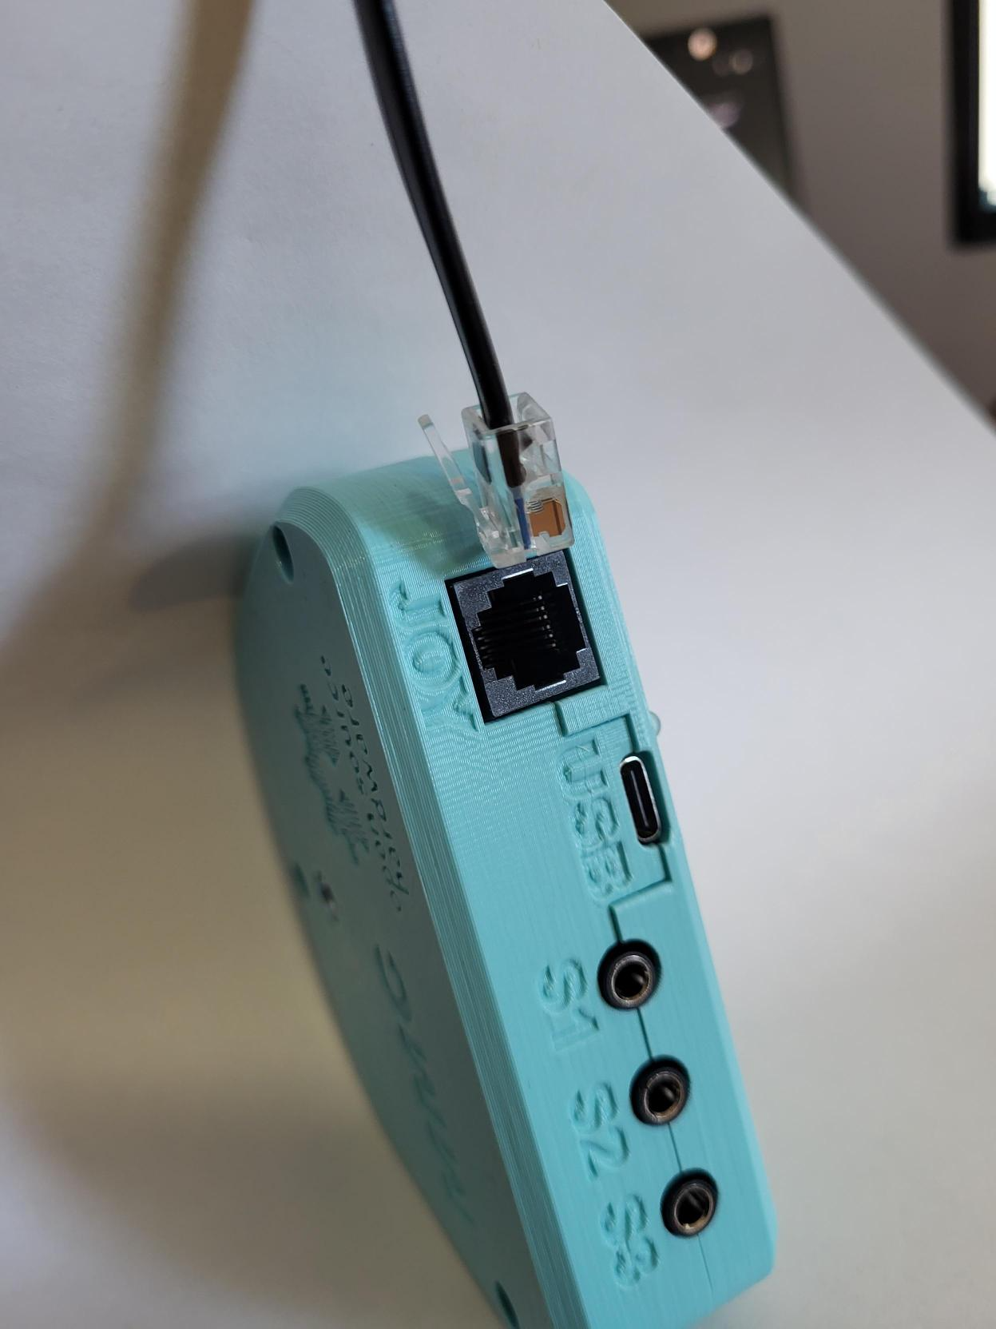

If the cable is damaged or a different length is required, the Willow Interface Cable is a standard RJ11 phone cable.

#### Optional: Connect Assistive Switches to the Willow Hub

The Willow Hub has three 3.5 mm ports for connecting external assistive switches. The three ports are labelled S1, S2, and S3. You can plug a switch into any combination of, or all the assistive switch ports as needed.

By default, an assistive switch attached to S1 will do a left click, and an assistive switch attached to S3 will do a right click when in mouse mode. A full summary of the Assistive Switch mapping is available in the Assistive Switch Inputs section.

After completing these steps, the Willow is now ready to connect to the Host Device which is outlined in the next section.

#### Optional: Set Up Wrist Ramp

Included with the print and design files for the Willow is a 3D printable wrist ramp. The wrist ramp is designed to raise the users hand to a level that they can comfortably use the Willow. If the provided ramp is the wrong size or otherwise uncomfortable, the design files for the ramp are provided, and all the design parameters are parametric, allowing the maker to size them to the user. A custom ramp can also be created out of foam.

## Connecting to Host Device

The Host Device is the computer, tablet, laptop, smartphone, or other device that the user wants to control with the Willow. How the Willow is connected will depend on the type of Host Device and whether the Willow is intended to operate as a USB Mouse, USB Gamepad, or Wireless Bluetooth Mouse.

The Willow requires both a communication connection and a power connection.

To connect to the Host Device, you must first ensure that the device is powered, then check what mode it is in and change through the menu if required.

### Powering the Device

The Willow requires an external power source. Users can draw power from the host device (except on iOS devices) or use a USB power bank via the USB port on the Hub. The Willow is provided with a USB-C to USB-A cable. Depending on the host device and operating mode, a suitable adapter or USB-C to a specific USB plug type cable may be required.

The general set-up will look like the following for any operating mode, where the required connection or adapter will vary depending on how you want to connect the device. When in Wireless mode, the Willow can be connected directly to any power source.

See the below table for compatible power connection types for common host devices.

|  |  |  |  |  |
| --- | --- | --- | --- | --- |
| Common Host Devices | Power Connections | | Common Cables for Direct Connection to Host Device | Common Adapters for Splitting to External Power |
| Direct to Host Device | Using External Power Source |
| Windows PC | Checkmark with solid fill | Checkmark with solid fill | USB-C to USB-C | [Male USB 2 to Dual Female USB 2 Splitter](https://www.amazon.ca/Female-Splitter-Power-Extension-Adapter/dp/B07CKQSTCB/ref=asc_df_B07CKQSTCB/?tag=googleshopc0c-20&linkCode=df0&hvadid=578878818136&hvpos=&hvnetw=g&hvrand=1902237527754843685&hvpone=&hvptwo=&hvqmt=&hvdev=c&hvdvcmdl=&hvlocint=&hvlocphy=9001202&hvtargid=pla-570612962393&psc=1&mcid=0bc08d89f82c34bb801670843c9934bd) |
| USB-A to USB-C |
| Mac | Checkmark with solid fill | Checkmark with solid fill | USB-C to USB-C | [USB-C Splitter](https://www.amazon.ca/Adapter-Charging-Compatible-Samsung-Galaxy/dp/B09CTSHZR7/ref=asc_df_B09CTSHZR7/?tag=googleshopc0c-20&linkCode=df0&hvadid=579290833365&hvpos=&hvnetw=g&hvrand=14573702412268645434&hvpone=&hvptwo=&hvqmt=&hvdev=c&hvdvcmdl=&hvlocint=&hvlocphy=9001202&hvtargid=pla-1657307472955&mcid=61dcfe0809cc31e6a912e42158bb3f1f&th=1) |
| Android Phone/Tablet | Checkmark with solid fill | Checkmark with solid fill | USB-C to USB-C | [USB-C Splitter](https://www.amazon.ca/Adapter-Charging-Compatible-Samsung-Galaxy/dp/B09CTSHZR7/ref=asc_df_B09CTSHZR7/?tag=googleshopc0c-20&linkCode=df0&hvadid=579290833365&hvpos=&hvnetw=g&hvrand=14573702412268645434&hvpone=&hvptwo=&hvqmt=&hvdev=c&hvdvcmdl=&hvlocint=&hvlocphy=9001202&hvtargid=pla-1657307472955&mcid=61dcfe0809cc31e6a912e42158bb3f1f&th=1) |
| USB-C to USB-B Micro | [Male USB-B Micro to Dual Female USB 2 Splitter](https://www.amazon.ca/dp/B06WPBSWHB/ref=sspa_dk_detail_3?psc=1&pd_rd_i=B06WPBSWHB&pd_rd_w=cUGe5&content-id=amzn1.sym.d8c43617-c625-45bd-a63f-ad8715c2c055&pf_rd_p=d8c43617-c625-45bd-a63f-ad8715c2c055&pf_rd_r=9QEV2KBKKPGTJR4XZGY8&pd_rd_wg=ZJ0Gd&pd_rd_r=795a6ec9-c479-434d-b70d-41684a87e571&s=electronics&sp_csd=d2lkZ2V0TmFtZT1zcF9kZXRhaWw) |
| Apple Phone/Tablet |  | Checkmark with solid fill | USB-C to Lightning | [Lightning to USB 3 Adapter](https://www.apple.com/ca/shop/product/MK0W2AM/A/lightning-to-usb-3-camera-adapter) |
| USB-C to USB-C | [USB-C Splitter](https://www.amazon.ca/Adapter-Charging-Compatible-Samsung-Galaxy/dp/B09CTSHZR7/ref=asc_df_B09CTSHZR7/?tag=googleshopc0c-20&linkCode=df0&hvadid=579290833365&hvpos=&hvnetw=g&hvrand=14573702412268645434&hvpone=&hvptwo=&hvqmt=&hvdev=c&hvdvcmdl=&hvlocint=&hvlocphy=9001202&hvtargid=pla-1657307472955&mcid=61dcfe0809cc31e6a912e42158bb3f1f&th=1) |

More detailed instructions for how to connect the Willow to various host devices in different modes are found below.

Once the Willow is connected to power, it will turn on automatically. The Hub will emit a start-up tone and the Hub Display will show the current code version and the current operating mode. The Joystick must be plugged into the Hub for the device to fully power on.

#### Changing the Operating Mode

The Willow can operate in three modes: USB Mouse, Wireless Bluetooth Mouse, and USB Gamepad. The current operating mode is indicated on the display on startup and by the color of the Operating Mode Indicator. The default operating mode is USB Mouse.

|  |  |
| --- | --- |
| Operating Mode | Operating Mode Indicator |
| USB Mouse | Purple |
| Wireless Mouse | Blue (Solid = connected, flashing = searching) |
| USB Gamepad | Yellow |

To change the operating mode, use the Hub Display menu. For an explanation on how to perform the given inputs, see the section on How to Perform Willow Inputs. To enter and navigate the menu:

|  |  |  |
| --- | --- | --- |
| Output | Input | |
| **Assistive Switch** | **On Hub Button** |
| Enter/Exit menu | S1 very long press  (>3 seconds) | Select very long press (>3 seconds) |
| Enter/Exit Menu | Simultaneous Press of S1 and S3 | Simultaneous Press of Next and Sel |
| “Next” – goes to next option | S3 | Next |
| “Select” – Selects the current option | S1 | Sel |

#### Connecting in USB Mouse Mode

Using the Hub Menu, ensure you are in USB Mouse mode. This is the default setting when the device is first programmed. When in USB Mouse mode, the operating mode indicator will turn purple.

**Plugging Direct into a Computer or Laptop**

If you have the appropriate cable, the Willow can be directly plugged into the device’s USB port to work in USB Mouse or Gamepad mode. The Hub port requires a USB-C plug, and most host devices will require either USB-A or USB-C plug types.

The order in which you connect the USB cables may affect how the Willow works. Connect the cables in the following order:

1. Connect the Willow Interface Cable to the Willow Joystick and Willow Hub.
2. Connect a cable with a USB-C connection to the Willow Hub, and the other end (either USB-C or USB-A) to the host device.
3. Wait 3 seconds for the Willow to initialize. Initialization is complete when the Hub Display reads “Ready for use”.

#### Plugging Direct into an Android Mobile Device

The Willow can be directly plugged into the device’s USB port to work in USB Mouse or Gamepad mode using the appropriate cable and/or adapter. The Hub port requires a USB C plug, and most host devices will require either USB-C, USB-B Micro, or USB-A plug types.

1. Connect the Willow Interface Cable to the Willow Joystick and Willow Hub.
2. Connect a cable with a USB-C connection to the Willow Hub, and the other end (depending on the device) to the host device.
3. Wait 3 seconds for the Willow to initialize. Initialization is complete when the Hub Display reads “Ready for use”.

#### Plugging into an iOS or Android Mobile Device with an External Power Source

The Willow cannot draw power from an iOS device, and therefore must have a powered USB hub or powered USB splitter to connect between the Willow Hub and iOS device. For an Android mobile device (phone or tablet), using an external power source is optional, but can extend the battery life of your device.

The order in which you connect the USB cables may affect how the Willow works. Connect the cables in the following order if using an external power source:

1. Connect the Willow Interface Cable to the Willow Joystick and Willow Hub.
2. Connect a USB-C cable to the Willow Hub and plug the other end into a USB Splitter or Powered Adapter. Connect the USB Splitter to power with the required cable.
3. Connect the other end of the splitter/adapter into the host device (USB-C or USB-B micro).
4. Wait 3 seconds for the Willow to initialize. Initialization is complete when the Hub Display reads “Ready for use”.

Note that to use the Willow with an iOS device, the device must have AssistiveTouch within the Accessibility Settings turned on. Instructions for this are in the Set Up Host Device Section.

#### Connecting in Wireless Mouse Mode

Using the Willow as a Wireless Bluetooth Mouse requires a Bluetooth-compatible Host Device and an external power source. In Wireless Mouse Mode, the Willow can be paired by a different host device, a USB Power Bank, or a USB wall power adapter.

The Willow will need to be initially paired with the Host Device using the Host Device interface, which will likely require additional assistance. Once the Willow is paired to a Host Device, it will automatically reconnect if the power is turned off and on again.

Use the following steps to connect in Wireless Mouse Mode:

1. Connect the Willow Interface Cable to the Willow Joystick and Willow Hub.
2. Connect the Willow Hub to a power source through the USB-C cable.
3. Wait 3 seconds for the Willow to initialize. Initialization is complete when the Hub Display screen reads “Ready for use”.
4. If necessary, activate the Hub Menu and change the operating mode to BT Mouse mode.

#### Pairing the Willow to a Bluetooth-Compatible Host Device

When the Willow is in Wireless Mouse mode, it will automatically advertise itself as “Willow”. The Operating Mode Indicator will flash blue indicating it is ready to pair.

On the host device:

1. Confirm that Bluetooth is activated.
2. Navigate to ***Settings*** > ***Bluetooth***
3. Tap on Willow to pair.
4. A ***Connected*** message will show beside the device name when it successfully connects.

Once paired, the indicator will remain a solid blue.

Note: that when pairing with an iOS device, the device must have AssistiveTouch within the Accessibility Settings turned on to use the paired Willow. Instructions for this are in the Set Up Host Device Section.

##### **Reconnecting the Willow to a Bluetooth-Compatible Host Device**

If the Willow is powered off, it will automatically reconnect to the previously paired Bluetooth Host Device when the Willow is powered on again.

##### **Disconnecting the Willow from a Bluetooth-Compatible Host Device**

If you no longer wish to use the Willow with a particular device, you will need to disconnect the Willow using the Bluetooth settings on the Bluetooth Compatible Host Device.

#### Connecting in USB Gamepad Mode

Gamepad mode is available through USB connection only and is compatible with any device that supports USB-HID connection. The Willow Hub can be connected directly to a Computer, Laptop, or Android device in the same way as in USB Mouse Mode.

Using the menus through the Hub Display, ensure you are in Gamepad mode. USB Mouse mode is the default setting when the device is first programmed. When in Gamepad mode, the operating mode indicator will turn yellow.

When connecting to the Xbox Adaptive Controller (XAC), the XAC must be connected and paired with a device for the Willow to receive power and function. The Willow Hub can be plugged into either the left or right USB Joystick inputs. The following table links to resources for using the XAC and configuring controllers in Steam, a gaming platform.

|  |  |
| --- | --- |
| QR Code | Resource |
| A QR code on a white background linking to accessible gaming resources. | [Adaptors for XAC compatibility with other systems.](https://www.makersmakingchange.com/s/managed-content-news/assistive-technology-in-gaming-MCTUYK7YHG6NFNTHPTBE7U5J4RTM) |
| A QR code on a white background linking to how to remap LipSync inputs | [Guide for remapping Willow inputs with the XAC.](https://www.youtube.com/watch?v=gm4w4qXaDm8) |
| A QR code on a white background linking to how to configure a controller in steam | [Guide for configuring a controller in Steam.](https://partner.steamgames.com/doc/features/steam_controller/getting_started_for_players) |

### Setting Up Host Device

There may be settings on the host device that enable the Willow to be used more easily and/or more effectively.

**Enable On-Screen Controls –** Enables access to functions that usually require physical access to the device.

**Enable On-Screen Keyboard –** Provide a keyboard for inputting characters.

**Adjust Host Device Cursor Size –** Increasing cursor size can make it easier to see.

**Adjust Host Device Cursor Speed –** The cursor speed is adjustable on some devices. The cursor speed can also be adjusted separately on the Willow.

**Adjust Host Device Double Click Speed –** Increasing the allowable delay between clicks may make it easier to input a double click.

**Enable On-Screen Controls**

The assistant menu is a floating onscreen menu that allows access to important functions that cannot be accessed without physically touching the device, like the home button, back, zoom in and out, screen capture, volume, and restart.

**On Android devices**, turn on the Assistant Menu/ Accessibility Menu by going to Setting → Accessibility → Dexterity and Interaction → Assistant Menu

**On iOS devices**, turn on AssistiveTouch by going to Settings → Accessibility → Touch → AssistiveTouch



*Android device*

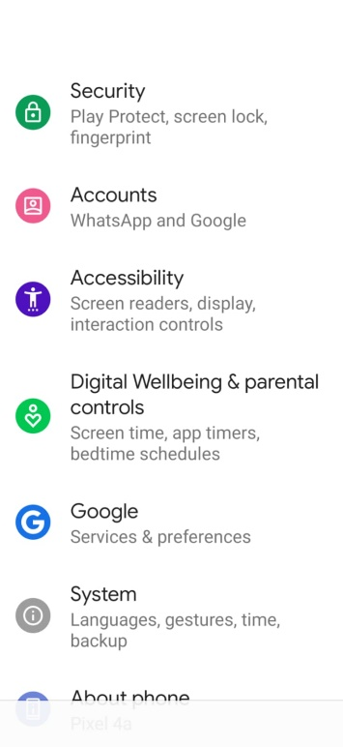

*iOS device*

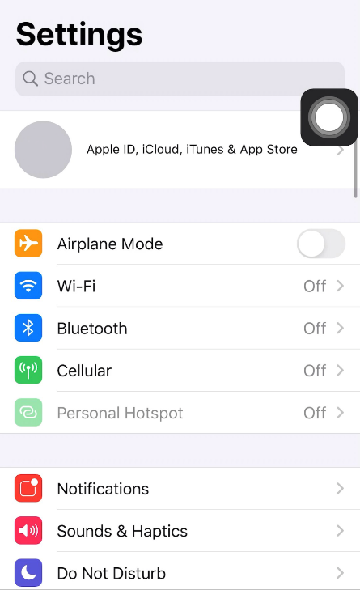

On some devices, a swiping action is required to unlock it. This can be avoided by turning off screen lock. Alternatively, applications such as **Keep Screen On** can be downloaded from the Android Play store to prevent the phone from going to sleep. However, this will drain your phone battery faster.

|  |  |
| --- | --- |
| QR Code | Resource |
| iPhone Accessibility features QR code. | [iPhone accessibility features.](https://support.apple.com/en-ca/guide/iphone/iph3e2e4367/ios) |
| Android accessibility features QR code | [Android accessibility features.](https://www.android.com/intl/en_ca/accessibility/) |
| Windows Accessibility features QR code | [Windows accessibility features.](https://support.microsoft.com/en-us/windows/discover-windows-accessibility-features-8b1068e6-d3b8-4ba8-b027-133dd8911df9) |
| MAC accessibility features QR Code | [Mac accessibility features.](https://support.apple.com/en-ca/guide/mac-help/mh35884/mac) |

## Operating the Willow

The Willow has a range of inputs including the joystick, optional assistive switches, and the buttons on the Hub. Using these inputs, the user, or support person, can adjust settings, change modes, and access the various output actions available in each mode.

### How to Perform Willow Inputs

The Willow has a range of inputs available through the joystick, assistive switches, and Hub buttons. This section outlines how to perform each input type.

#### Moving The Joystick

To use the joystick, move the joystick in the desired direction. The further the joystick is moved, the faster the cursor will move. When the joystick is released, it will return to its resting position.

#### Using External Assistive Switches

Up to three External Assistive Switches with standard 3.5 mm audio jack connections can be used with the Willow to provide input. The Assistive Switches are connected to the Willow Hub via the external switch ports labeled S1, S2, and S3.

#### Using the Hub Buttons

The Hub Buttons provide two functions: they provide a way to navigate the Hub Menu and they enable a support person to perform the same actions as the assistive switches without having to use the user’s assistive switches.

To activate the Hub Buttons, simply press down and then release on one or both of the round buttons on the face of the Hub. Next and Select (Sel) are both mapped to S1 and S3, respectively.

#### Timed Inputs

The amount of time that any input (switches/buttons) is held before being released will trigger different actions.

**Short**: Less than 1 second. Indicated by the respective LED blinking once.

**Long**: Between 1 to 3 seconds. Indicated by the respective LED lighting up and staying on.

**Very Long**: 3 seconds or longer. Indicated by the respective LED turning back off.

For each input in regular operating modes, a specified Feedback Light will indicate the input duration. The feedback lights are designated to the inputs as follows:

**Left Light** •: S1, Select (Sel) button on Hub

**Middle Light** ••: S2

**Right Light** •••: S3, Next button on Hub

For example, to perform a Very Long S1, press and hold the assistive switch connected to S1. After you hold the switch for 1 second, the Right Feedback Light on the Hub will turn on. After 3 seconds, the Right Feedback Light will turn off. Release the switch to trigger a Very Long S1.

### USB & Wireless Mouse Mode

In either USB or Wireless Mouse Mode, the joystick controls the cursor, and the assistive switches are mapped to different mouse button clicks.

**Mouse Mode Functions**

|  |  |
| --- | --- |
| Function | Description |
| Moving the Cursor | Performs the same function as moving a mouse to move the pointer/cursor on the screen. |
| Left Click | Performs the same function of the left click on a mouse |
| Right Click | Performs the same function of the right click on a mouse |
| Middle Click | Performs the same function of the scroll wheel push on a mouse |
| Drag Mode | Will mimic the left click on the mouse held down to drag items on the screen such as folders |
| Scroll Mode | Keeps the mouse stationary and the joystick can control the scroll speed |

#### Moving the Cursor

To move the cursor, move the joystick in the desired direction. The further the joystick is moved, the faster the cursor will move. Releasing the joystick will return it to the center position and the cursor will stop moving.

If the cursor continues to move after the joystick is released see the Troubleshooting Section: page 33.

#### Left Clicking

To do a left click, do a short press of the Hub “Select” button or S1.

#### Right Clicking

To do a right click, do a short press of the Hub “Next” button or S3.

#### Double Clicking

To do a double click, do two short press of the Hub “Select” button or S1. The left LED will blink once for each press.

It may be helpful to decrease the double click speed on the host device.

#### Middle Clicking

Middle click is used for tasks such as turning the cursor into scroll mode in web browsers and in documents. On a typical mouse, a middle click is accomplished by clicking the scroll wheel. Note that not all mice have a scroll wheel that clicks.

To do a middle click, apply and maintain a very long press of the S3 switch or Hub “Next” button (At least 3 seconds). The right-side LED will begin flashing quickly once the duration has been reached.

A middle click can also be generated by a short press of S2.

#### Drag

Drag is used for tasks such as repositioning windows or icons, or selecting objects such as text. On a typical mouse, drag is accomplished by pressing and holding the left click. On the Willow, drag is accomplished by starting Drag mode.

To start Drag Mode, apply and maintain long press (between 1 and 3 seconds) of the Hub “Select” button, or a long press of S1.and then release the press. The Left Feedback Light will turn on and stay on once the duration has been reached.

To drag, move the joystick in any direction.

To stop drag mode, apply a short press of S1 or S3.

#### Vertical Scroll

Vertica scroll is useful for scrolling up and down within documents or webpages. On a typical mouse, this is often controlled by rotating a scroll wheel. On the Willow, vertical scrolling is accomplished by activating Scroll Mode and using vertical motion of the joystick.

To activate Scroll Mode, input long press of S3 (between 1 and 3 seconds). The Right Feedback Light will turn on when the threshold has been reached

To scroll, move the joystick up or down. The further the joystick is moved, the faster the scroll.

To stop scroll mode, apply a short press of S1 or S3.

### USB Gamepad Mode

In Gamepad mode, the Willow inputs are translated to gaming outputs instead of mouse functions. The Willow will act as a gamepad with one joystick and 6 buttons.

In some direct applications, these buttons will have default functions, such as when plugged into the XAC, or plugged into a mobile smart phone. When used with a program such as Steam, the inputs will have to be mapped to the desired outputs to setup the Willow as a controller. Note that while the Willow inputs are set to default outputs with the XAC, you can modify this mapping through the [Xbox Accessories App.](https://support.xbox.com/en-CA/help/account-profile/accessibility/customize-adaptive-controller-in-xbox-accessories-app)

**Gamepad Mode Functions**

|  |  |
| --- | --- |
| Function | Description |
| Moving the Joystick | Performs the same function as moving a standard joystick or thumbstick in gaming applications. |
| Button 1 Press | Performs the same function of pressing button 1 on a standard gamepad. |
| Button 2 Press | Performs the same function of pressing button 2 on a standard gamepad. |
| Button 3 Press | Performs the same function of pressing button 3 on a standard gamepad. |
| Button 4 Press | Performs the same function of pressing button 4 on a standard gamepad. |
| Button 5 Press | Performs the same function of pressing button 5 on a standard gamepad. |
| Button 6 Press | Performs the same function of pressing button 6 on a standard gamepad. |

#### Moving the Joystick

To move the joystick, move the joystick in the desired direction. The further the joystick is moved, the further the gamepad joystick will move. Releasing the joystick will return it to the center position and the gamepad joystick will return to center.

If the cursor continues to move after the joystick is released see the Troubleshooting Section: page 34.

#### Button 1 Press

To do a button 1 press, do a short (less than 1 second) press of S1 or the Hub “Select” button. The button 1 press will be generated when the button or switch is released.

#### Button 2 Press

To do a button 2 press, do a short (less than 1 second) press of S3 or the Hub “Next” button. The button 2 press will be generated when the button or switch is released.

#### Button 3 Press

To do a button 3 press, do a long (between 1 and 3 seconds) press of S1 or the Hub “Select” button. The button 3 press will be generated when the button or switch is released.

#### Button 4 Press

To do a button 4 press, do a long (between 1 and 3 seconds) press of switch S3 or the Hub “Next” button and then release. The button 4 press will be generated when the button or switch is released.

#### Button 5 Press

To do a button 5 press, do a very long (between 1 and 3 seconds) press of the Hub “Select” button or a short (less than 1 second) press of the S2 switch. The button 5 press will be generated when the button is released.

#### Button 6 Press

To do a button 6 press, perform a long press (between 1 to 3 seconds) of S2. The button 6 press will be generated when the long press of S2 is released.

### USB Gamepad Mode connected to an Android Smart Phone or Tablet

When connected to a smart phone in Gamepad Mode, the Willow acts similar to switch scanning but uses the joystick to move the scanning target.

| Function | Description |
| --- | --- |
| Moving the Scanning Target | Moves the target selector around the screen one target at a time, side to side, or up and down. |
| Select | Performs the same function as tapping on the selected field. |
| Back | Performs the same function as the back button on an Android smart phone. |

#### Moving the Scanning Target

To move the scanning target, move the joystick in one of the four cardinal directions: up, down, left, or right. If the joystick is held in the chosen direction, the selection field will move in that direction, highlighting the different apps or selections as it goes.

#### Select

To select the highlighted field, do a short press of the Hub “Select” button or assistive switch S1.The Select function will be performed when the short press is released.

#### Back

To use the Back function, do a short press of the Hub “Next” button or assistive switch S3. The Back function will be performed when the short press is released.

### Mapping Summary

The overall mapping of the Willow inputs and feedback features is as follows:

**Feedback Features**

Each Feedback Light is designated to a set of inputs:

**Left Light** •: S1, Select (Sel) Hub button

**Middle Light** ••: S2

**Right Light** •••: S3, Next Hub button

The time durations Short, Long, and Very Long for the switch/button inputs are the following:

**Short**: Less than 1 second. Feedback Light blinks once when released.

**Long**: Between 1 to 3 seconds. Feedback Light turns on and stays on.

**Very Long**: 3 seconds or longer. Feedback Light turns back off.

**Assistive Switch Inputs**

| Willow Assistive Switch Inputs | Hub Menu | Mouse  (PC or Mobile) | Gamepad | | | |
| --- | --- | --- | --- | --- | --- | --- |
| **PC** | **Mobile (Android)** | **XAC (Left USB)** | **XAC (Right USB)** |
| S1 Short Press | Select | Left Click | Button 1 | Select | X1 (Left Stick Up) | View |
| S1 Long Press | N/A | Start Drag Mode | Button 3 | Select | Left Stick Press | Right Stick Press |
| S1 Very Long Press | Exit Hub Menu | Enter Hub Menu | Enter Hub Menu | Enter Hub Menu | Enter Hub Menu | Enter Hub Menu |
| S2 Short Press | N/A | Middle Click | Button 5 | Back | A | X |
| S2 Long Press | N/A | N/A | Button 6 | N/A | B | Y |
| S2 Very Long Press | N/A | Perform Center Reset | Perform Center Reset | Perform Center Reset | Perform Center Reset | Perform Center Reset |
| S3 Short Press | Next | Right Click | Button 2 | Select | X2 (Left Stick Down) | Menu |
| S3 Long Press | N/A | Start Scroll Mode | Button 4 | N/A | Left Bumper | Right Bumper |
| S3 Very Long Press | N/A | Middle Click | N/A | Select | N/A | N/A |
| Chorded Inputs (Simultaneous short press) | | | | | | |
| S1 and S3 | Exit Hub Menu | Enter Hub Menu | Enter Hub Menu | Enter Hub Menu | Enter Hub Menu | Enter Hub Menu |

**Hub Button Inputs**

| Willow Hub Button Inputs | Hub Menu | Mouse  (PC or Mobile) | Gamepad | | | |
| --- | --- | --- | --- | --- | --- | --- |
| **PC** | **Mobile (Android)** | **XAC (Left USB)** | **XAC (Right USB)** |
| Select Short Press | Select | Left Click | Button 1 | Select | X1 (Left Stick Up) | View |
| Select Long Press | N/A | Start Drag Mode | Button 3 | Select | Left Stick Press | Right Stick Press |
| Select Very Long Press | Exit Hub Menu | Enter Hub Menu | Enter Hub Menu | Enter Hub Menu | Enter Hub Menu | Enter Hub Menu |
| Next Short Press | Next | Right Click | Button 2 | Back | X2 (Left Stick Down) | Menu |
| Next Long Press | N/A | Start Scroll Mode | Button 4 | N/A | Left Bumper | Right Bumper |
| Next Very Long Press | N/A | Middle Click | Button 5 | Select | A | X |
| Chorded Inputs (Simultaneous short press) | | | | | | |
| Next and Select | Exit Hub Menu | Enter Hub Menu | Enter Hub Menu | Enter Hub Menu | Enter Hub Menu | Enter Hub Menu |

Note: Default XAC mappings can be modified through the [Xbox Accessories App.](https://support.xbox.com/en-CA/help/account-profile/accessibility/customize-adaptive-controller-in-xbox-accessories-app)

## The Hub Menu

The Hub is an interface device used to connect the Willow joystick and assistive switches to the Host Device. The Hub also contains a display that shows the Hub Menu, an interface for adjusting settings, calibrating the joystick, changing the operating mode, restarting the device, and resetting to the default settings.

### Accessing the Hub Menu

The Hub Menu is normally off to reduce power consumption and wear on the screen. To use the Hub Menu, it must first be activated using assistive switches, or the Hub Buttons. The following table shows the corresponding input options to enter/exit the Hub Menu.

|  |  |  |
| --- | --- | --- |
| Action | Input | |
| **On Hub Button** | **Assistive Switch** |
| Enter/Exit menu | Select very long press (>3 seconds) | S1 very long press (>3 seconds) |
| Enter/Exit Menu | Simultaneous Press of Next and Sel | Simultaneous Press of S1 and S3 |

### Navigating the Hub Menu

Once the Hub Menu is activated, it will display a list of menus. The current selection will be indicated by a left arrow (>). The Hub Menu is navigated using inputs from assistive switches, and/or the Hub Buttons. The following table shows the corresponding input options to navigate the Hub Menu.

|  |  |  |
| --- | --- | --- |
| Action | Input | |
| **On Hub Button** | **Assistive Switch** |
| “Next” – goes to next option | Next | S3 |
| “Select” – Selects the pointed to option | Sel | S1 |

When “Next” is activated, the selection will change to the next item on the list. If “Next” is activated when the selection is on the last item of the list, the selection will change to the top item on the list. A “Next” action is trigged using a short press on S3, or by pressing the Next button on the Hub.

When “Select” is activated, the current selection will be activated, such as opening a submenu, starting calibration, etc. The “Select” action is trigged using a short press on S1, or by pressing the Select button on the Hub.

### Hub Menu Options

The Hub Menu is arranged as sets of submenus and pages. Each submenu has a “… Back” option at the end of its list to return to the top of the previous menu. Any selection made will walk you through the required steps with instructions on the Hub Display. The overall structure of the Hub Menu is as follows:

* Exit Menu
* Calibrate
  + Center Reset
  + Full calibration
* Change Mode
  + Mouse USB
  + Mouse BT
  + Gamepad
* Mouse cursor speed
  + Increase
  + Decrease
* More
  + Sound
  + Restart Willow
  + Factory Reset

#### Exit Menu

The top menu item is to exit and deactivate the Hub Menu. After performing any other setting changes, or backing out of submenus, the menu display will always return to the top of the main menu, so it is easy to exit the menu after changing settings. When selected, you will be asked to confirm you wish to leave the menu and can select “Confirm” to exit, or “… Back” to return to the menu.

As shown in the table for navigating the menus, any function used to enter the menu, can also be used to exit it.

#### Calibrate

The Calibrate submenu contains the options “Center Reset” and “Full Calibration.”

A center reset will reset the neutral resting position of your joystick and should be used if you are experiencing drift. Do not touch the joystick while performing a center reset.

A full calibration resets the neutral and extent positions of your joystick and should be done if you are having issues moving in certain directions with the joystick.

#### A capture of the screen on the LipSync showing it is in USB mouse modeChange Mode

The Change Mode submenu allows you to select one of three modes: USB Mouse, BT Mouse, or Gamepad. Note that it is important to ensure you are in the correct mode for the device you want to connect to. After changing modes, the Hub will reset and perform a center reset upon powering on. Do not touch the joystick until you see the Hub display read “Ready for use” and the mode.

#### Mouse Cursor Speed

The Mouse Cursor Speed submenu allows you to increase or decrease the mouse cursor speed in increments of 1 from a scale of 0 to 10. While changing the increment, the cursor can still be moved across the screen to test the current speed setting.

#### More

The More submenu contains further submenus for settings that likely won’t be used as often.

The current features included are Sound On/Off, Restart Device, and Factory Reset:

* Sound On/Off will toggle the sound feedback for Willow inputs on or off. There is no volume control.
* Restart device is a way to power the device off and on again without unplugging it from power.
* Factory reset will return all settings back to default. This includes the operating mode, cursor speed, calibrations, and any settings adjusted through the API. It is suggested to perform a full calibration after a factory reset.

### Adjusting the Willow

Adjustments to the Willow involve calibrating the joystick and changing settings. To adjust the Willow, most settings can be changed through the Hub Display menu.

#### Center Reset

A Center Reset resets the neutral position of the joystick in its resting position. If the position of the cursor is moving when the joystick is released and stationary, a Center Reset can help resolve the cursor drift.

A Center Reset should be performed in the following situations:

1. The Willow mounting angle is adjusted.
2. The Willow topper is replaced.
3. The cursor continues to move when the topper is released and is stationary.

A Center Reset is automatically performed when the Willow is first powered on, and at the end of the Full Calibration process. A Center Reset can also be started manually using the Hub Menu or outside of the menu using a Very Long Press on an Assistive Switch attached to S2:

1. **Using the Hub Menu:**
   1. Activate the Hub Menu by applying a very long (>3 seconds) press on the Select Button or S1 and then release it.
      1. An alternative way to open the Hub Menu is a simultaneous short press of S1 and S3, or Next and Select on the Hub.
   2. The Hub Menu will turn on.
   3. Use a short press of the Next button or S3 to move through the Menu options until you reach “Calibration.”
   4. Use a Short (<1 seconds) press of the Select Button or S1 to select “Calibration.”
   5. Use a Short (<1 seconds) press of the Select Button or S1 to select “Center Reset.”
   6. Release the joystick and do not touch it until the menu screen returns to the regular menu.
2. **Using Long Press on Assistive Switch S2:**
   1. Perform a Very Long Press (>3 seconds) of S2.
   2. Release the joystick and do not touch it until the Hub screen states that the center reset is complete.

When the Center Reset is started, the Hub Menu Display will prompt you to not touch the joystick. It is important to release the joystick and leave it to sit in its neutral resting position to perform the center reset.

#### Full Calibration

The Full Calibration of the Willow should be completed upon initial assembly of the device. It may also need to be repeated if the user is experiencing strange cursor movements or no change in movement at the extents of the joystick.

The calibration procedure is a timed process that required the joystick to be moved to each corner of the movement range. The Hub menu display will give prompts to follow for moving the joystick.

1. **Initiate Full Calibration**
   1. Apply and maintain a very long (>3 seconds) press of the Select Button or S1 and then release it.
      1. An alternative way to open the Hub Menu is a simultaneous short press of S1 and S3, or Next and Select on the Hub.
   2. The Hub Menu will turn on.
   3. Use a short (<1 second) press of the Next button or S3 to move through the Menu options until you reach “Calibration”
   4. Use a short (<1 second) press of the Sel Button or S1 to select “Calibration”
   5. Use a short (<1 second) press of the Next button or S3 to move through the Menu options until you reach “Full Calibration.”
   6. Use a short (<1 second) press of the Sel Button or S1 to select “Full Calibration”
   7. Release the joystick and follow the prompts on the Hub Menu Display.
2. **Follow Full Calibration Prompts**
   1. The Hub Display will show “Follow on screen prompts”
   2. The Hub will beep once, all lights will flash once, and the Display will show “Hold joystick top left”
      1. Move the joystick to the top left corner extent and hold it there until the prompt changes, also signified by the Hub beeping once and all lights flashing once.
   3. The Hub Display will show “Hold joystick top right”
      1. Move the joystick to the top right corner and hold it there until the prompt changes.
   4. The Hub Display will show “Hold joystick bottom right”
      1. Move the joystick to the bottom right corner and hold it there until the prompt changes also signified by the Hub beeping once and all lights flashing once.
   5. The Hub Display will show “Hold joystick bottom left”
      1. Move the joystick to the bottom right corner and hold it there until the prompt changes also signified by the Hub beeping once, in a higher pitch, and all lights flashing once.
   6. The Hub Display will show “Release, do not move joystick”
      1. Release the joystick back to its neutral position and do not touch it.
3. **Calibration Complete**
   1. When the calibration is complete, the Hub Display will show “Joystick Calibrated” and then return to the main menu screen.
   2. You can test the joystick movement on the host device screen to ensure the calibration was successful.
   3. You can now continue through the menu settings or exit the menu and use your joystick.

#### Changing Willow Settings

There are numerous settings that control the operation of the Willow. Some of these settings can be adjusted independently through the Hub Menu.

**Table 1: Willow Settings**

|  |  |  |  |  |
| --- | --- | --- | --- | --- |
| Setting | Default | Min | Max | Note |
| Cursor Speed | 5 | 0 | 10 | Changes the cursor speed in any Mouse Mode. |
| Sound Feedback | On | Off | On | Turns the sound on or off. |
| Scroll Level | 5 | 0 | 10 | Changes the scrolling speed.  **Only adjustable through API, not Hub menu.** |
| Deadzone | 0.12 | 0.0 | 1.0 | Changes the distance the joystick must be moved from rest to cause cursor/gamepad movement.  **Only adjustable through API, not Hub menu.** |

#### Changing the Cursor Speed

To change the cursor speed, the host device settings can be adjusted, or the Willow cursor speed can be adjusted. To change the Willow cursor speed:

1. Apply and maintain a very long (>3 seconds) press of the Select Button or assistive switch S1 and then release it.
   1. An alternative way to open the Hub Menu is a simultaneous short press of S1 and S3, or Next and Select on the Hub.
2. The Hub Menu will turn on.
3. Use a short (<1 second) press of the Next button or S3 to move through the Menu options until you reach “Cursor speed”
4. Use a short (<1 second) press of the Sel Button or S1 to select “Cursor speed”
5. Use a short (<1 second) press of the Next button or S3 to move through the Menu options “increase” and “decrease”
6. Use a short (<1 second) press of the Sel Button or S1 to select “increase” or “decrease” as desired.
   1. Note: the minimum cursor speed level is 0, and the maximum is 10.
7. Test the cursor speed on the host device by moving the joystick while in the menu.
8. Once happy with the cursor speed, navigate to “…Back” using a short (<1 seconds) press of the Next button or S3.
9. Use a short (<1 second) press of the Sel Button or S1 to select “…Back”
10. Use a short (<1 second) press of the Sel Button or S1 to select “Exit Menu” or continue through the menu to adjust other settings.

### Input-Output Mapping

The mapping of inputs (e.g., short press, very long press) to actions (e.g., Right Click, Activate Menu) are currently fixed in code and not adjustable by the user.

### Changing Settings Through the Serial Interface (API)

All the user-adjustable settings of the Willow are accessible through the Serial Interface. This is a more challenging method intended only for advanced users. Refer to Appendix A for more information.

## Storage

When not in use, the Willow should be stored in a cool place out of direct sunlight.

## Care

The Willow is made of 3D printed plastic. Exposure to high heat may cause warping and/or negatively affect function. Extended exposure to sunlight will also weaken the plastic on the device.

The Willow contains electronics and is not waterproof. If the device becomes wet, make sure it is off and do not use it or power it on until it has completely dried. It may help to open any electronic enclosures to speed up drying and ensure it has completely dried.

### Cleaning the Willow

|  |  |
| --- | --- |
| **Cleaning the Willow Joystick**   * Wipe with a damp cloth * Don’t use abrasive cleaning materials * Don’t soak the Willow Joystick in any cleaning solutions * Don’t immerse the Willow Joystick | **Cleaning the Willow Hub**   * Wipe plastic enclosure with a damp cloth * Don’t scrub or press down on the Hub Display * Don’t use abrasive cleaning materials * Don’t soak the Willow Hub in any cleaning solutions * Don’t immerse the Willow Hub in any liquids |

# Troubleshooting

**Willow turns on, and initial screen with version number appears, but second screen showing “Ready to Use” never appears, and no inputs are registering.**

* Ensure Willow Interface Cable is plugged into both the Hub and Joystick securely, then unplug the device and plug it back in.
* If this does not work, the joystick may need to be taken apart to ensure all sensors are plugged in and functioning. Refer to the Maker Guide to do this or reach out to the maker of the device.

**Mouse cursor is not visible**

* Make sure device is connected
* Make sure device is in proper operating mode (e.g., USB, not Wireless)
* Make sure the device has proper onscreen settings (e.g., AssistiveTouch on iOS)

**Mouse cursor is difficult to see**

* Adjust the size or color of the cursor on the host device

**Cursor movement is too slow or too fast**

* Adjust the cursor speed on the Willow
* Adjust the cursor speed on the host device

**Difficulty inputting a double-click**

* Adjust host devices double click rate

**Cursor / Joystick Drift**

* Trigger a center reset
  1. Through the Hub menu by navigating to **Calibrate > Center reset.**
  2. Using a very long press of assistive switch 2
  3. Disconnected and reconnect power.

# Contacting Support

1. Contact the person who made the device.
2. Email [info@makersmakingchange.com](mailto:info@makersmakingchange.com)

# Disposal

PLA filament may be industrially compostable in your area. Check with your waste management company if PLA can be composted or must be thrown in the garbage.

Disassemble the Willow and separate out the recyclable and compostable components, and those that must be thrown out. Electronics and batteries should be disposed of following your local waste management guidelines.

# Appendix A: Serial Interface (Application Programming Interface)

The Willow has an Application Programming Interface that can be used to change settings through a serial interface.

## Serial Interface Setup

To use the API, you will need a host device capable of supporting a serial connection and a serial terminal emulator program. The Arduino IDE[1] is a convenient option.

### Serial Settings

Select the appropriate COM port and set the speed to 115200.

## Sending Commands

Once the serial connection is established, text commands can be sent to the Willow. Make sure the line ending is set to ‘No Line Ending’. The commands should be sent in all capitals. Commands are sent in a two step process.

First, send the following command to activate the interface:

SETTINGS

If the serial connection is setup properly, the Willow will respond with:

SUCCESS,0:SETTINGS

Next, send the desired command. The command consists of a two letter end-point code followed by a comma and either a zero or a one. Then, a colon is used to separate the parameter. All of the end-points are listed in Table 2: Serial Interface Commands.

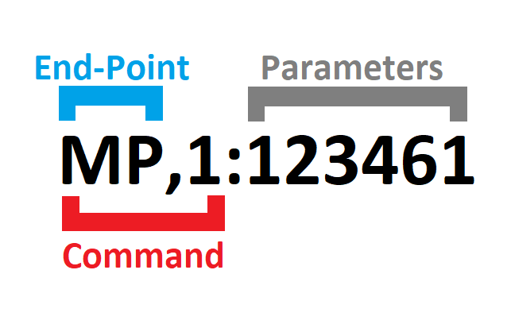

## API Format Willow Command List

|  |  |  |
| --- | --- | --- |
| Command | Success Response | Description |
| SETTINGS | SUCCESS,0:SETTINGS | Enter Settings mode |
| EXIT | SUCCESS,0:EXIT | Exit Settings mode |

Willow Commands

Table 2: Serial Interface Commands

| Command | Success Response | Description |
| --- | --- | --- |
| MN,0:0 | SUCCESS,0:MN,0:1 | Get Model number |
| VN,0:0 | SUCCESS,0:VN,0:V{N.NN} | Get version number (V{N.NN}) |
| OM,0:0 | SUCCESS,0:OM | Get operating mode (1 = USB Mouse, 2= USB Gamepad) |
| OM,1:{OM} | SUCCESS,1:OM | Set operating mode (1 = USB Mouse, 2= USB Gamepad) |
| LM,0:0 | SUCCESS,0:LM | Get light mode (0 = All LEDS off, 1 = Minimal LEDs, 2 = Normal LEDs) |
| LM,1:{LM} | SUCCESS,1:LM | Set light mode (0 = All LEDS off, 1 = Minimal LEDs, 2 = Normal LEDs) |
| SM,0:0 | SUCCESS,0:SM | Get sound mode (0 = Sound off, 1 = Basic Sound, 2 = All sounds |
| SM,1:{SM} | SUCCESS,1:SM | Set sound mode (0 = Sound off, 1 = Basic Sound, 2 = All sounds |
| SS,0:0 | SUCCESS,0:SS,0:{Cursor Speed Level} | Get the mouse cursor speed value (Level) |
| SS,1:{Cursor Speed Level:0-10} | SUCCESS,0:SS,1:{Cursor Speed Level} | Set the mouse cursor speed value (Level) |
| SL,0:0 | SUCCESS,0:SL,0:{Scroll Level} | Get the mouse scroll level value. |
| SL,1:{Scroll Level:0-10} | SUCCESS,0:SL,1:{Scroll Level} | Set the mouse scroll level value. |
| IN,0:0 | SUCCESS,0:IN,0:{ x|y } | Get joystick neutral values (x and y) |
| IN,1:1 | SUCCESS,0:IN,1:{ x|y } | Perform joystick center reset to set new joystick neutral values (x and y) |
| CA,0:0 | SUCCESS,0:CA,0:{ x0|y0, x1|y1, x2|y2, x3|y3, x4|y4 } | Get joystick calibration values (point 0, point 1, point 2, point 3, point 4) |
| CA,1:1 | SUCCESS,0:CA,1:{ x0|y0 } | Start joystick full calibration |
|  | SUCCESS,0:CA,1:{ x1|y1 } | Perform joystick calibration using command (Step 1) |
|  | SUCCESS,0:CA,1:{ x2|y2 } | Perform joystick calibration using command (Step 2) |
|  | SUCCESS,0:CA,1:{ x3|y3 } | Perform joystick calibration using command (Step 3) |
|  | SUCCESS,0:CA,1:{ x4|y4 } | Perform joystick calibration using command (Step 4) |
| DZ,0:0 | SUCCESS,0:DZ,0:{ DeadZone Factor 0.0 to 1.0 } | Get joystick deadzone (0.0 to 1.0) |
| DZ,1:{ Joystick DeadZone Factor 0.0 to 1.0} | SUCCESS,0:DZ,1:{ DeadZone Factor 0.0 to 1.0 } | Set joystick deadzone (0.0 to 1.0) |
| CM,0:0 | SUCCESS,0:CM,0:{Communication Mode} | Get communication mode value (  0=No HID Output,  1=USB mode enabled  2=Bluetooth mode enabled  ) |
| CM,1:1 | SUCCESS,0:CM,1:1 | Set communication mode value to 1 (USB mode enabled) |
| CM,1:2 | SUCCESS,0:CM,1:2 | Set communication mode value to 2 (Bluetooth mode enabled) |
| DM,0:0 | SUCCESS,0:DM,0:{Debug Mode} | Get debug mode value (  0=debug mode off,  1=joystick debug mode  3=button debug mode  4=switch debug mode  5=sip and puff debug mode  ) |
| DM,1:0 | SUCCESS,0:DM,1:0 | Set debug mode value to 0 (Disabled) |
| DM,1:1 | SUCCESS,0:DM,1:1 | Set debug mode value to 1 (joystick debug mode enabled) |
| DM,1:3 | SUCCESS,0:DM,1:3 | Set debug mode value to 3 (button debug mode enabled) |
| DM,1:4 | SUCCESS,0:DM,1:4 | Set debug mode value to 4 (switch debug mode enabled) |
| SR,1:1 | SUCCESS,0:RS,1:1 | Perform a soft reset. |
| FR,1:1 | SUCCESS,0:FR,1:1 | Perform factory reset |

#### Response Code

|  |  |  |
| --- | --- | --- |
| Response Status | Response Code | Description |
| SUCCESS | **0** | The command has successfully performed. |
| FAIL | **0** | The serial API mode is not enabled. Please enter the serial API mode. |
| FAIL | **1** | The requested command does not exist. Returns the response code and the requested parameter. |
| FAIL | **2** | The requested command exists, but the entered parameter is in incorrect format. Returns the response code and the requested parameter. |
| FAIL | **3** | The requested command exists, but the entered parameter is out of range. Returns the response code and the current value stored in the Flash. |

#### Debug Mode

|  |  |  |
| --- | --- | --- |
| Debug Mode | Debug Mode | Format |
| 0 | **Debug Mode Off** | None |
| 1 | **Joystick Debug Mode** | DEBUG,1:{ raw x| raw y, output x|output y} |
| 3 | **Button Debug Mode** | DEBUG,3:{ mainState, secondaryState, elapsedTime} |
| 4 | **Switch Debug Mode** | DEBUG,4:{ mainState, secondaryState, elapsedTime} |

|  |  |  |  |
| --- | --- | --- | --- |
| States | Buttons | Switches | Sip & Puff |
| secondaryState | Waiting = 0, Started = 1, Released = 2 | Waiting = 0, Started = 1, Released = 2 | Waiting = 0, Started = 1, Released = 2 |
| elapsedTime | Time in ms since start of current state | Time in ms since start of current state | Time in ms since start of current state |

#### Example

|  |  |  |
| --- | --- | --- |
| Input | Response | Note |
| SETTINGS | SUCCESS,0:SETTINGS | Willow Ready for API Command |
| VN,0:0 | SUCCESS,0:VN,0:30 | Willow return firmware version |

| INPUT | RESPONSE | ACTION |
| --- | --- | --- |
| SETTINGS | SUCCESS,0:SETTINGS | Willow Ready for API Command |
| PT,0:0 | SUCCESS,0:PT,0:2.5 | Willow return current puff pressure threshold of 2.5 hPa |
| SETTINGS | SUCCESS,0:SETTINGS | Willow Ready for API Command |

1. Available at no cost: <https://www.arduino.cc/en/software>